Clustering Analysis Documentation

Objective of Clustering
The goal of the clustering analysis was to identify distinct customer segments based on demographic characteristics, service usage, contract type, and billing behaviour. These segments were then analysed to understand differences in churn propensity.

Determining the Optimal Number of Clusters
Elbow Method
The Elbow Method was applied by fitting K-Means models with varying numbers of clusters (K = 1 to 9) and plotting the inertia values. Inertia measures within-cluster compactness.
The plot exhibited a noticeable reduction in inertia up to K = 5, after which improvements diminished. This indicates that five clusters provide a reasonable balance between model complexity and explanatory power.
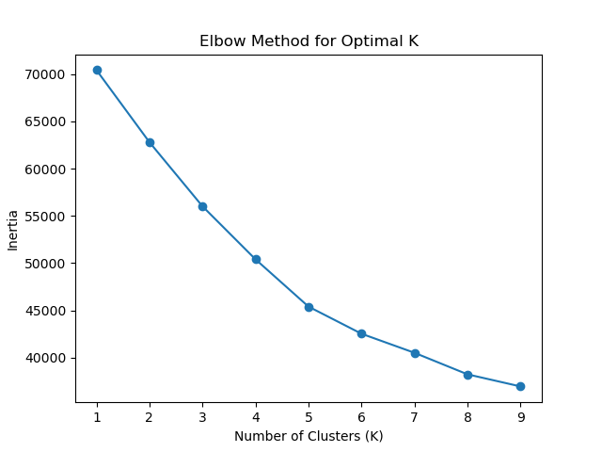
Silhouette Score Validation
To validate the chosen number of clusters, Silhouette Scores were calculated for K = 3, 4, and 5. The highest silhouette score was observed at K = 5, confirming that this configuration produced better-defined and more cohesive clusters.
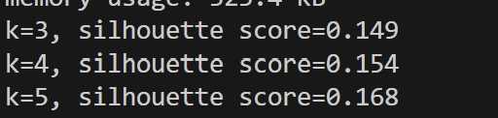

K-Means Model Training
Using the optimal number of clusters (K = 5), a K-Means clustering model was trained on the scaled feature set. Each customer was assigned a cluster label representing their segment membership. The resulting cluster labels were added to the dataset for further analysis.

Cluster Profiling and Interpretation
Cluster profiling was performed by calculating mean values of features for each cluster and analysing average churn rates. The analysis revealed meaningful differences across clusters, particularly in:
- Tenure
- Contract duration
- Internet service type
- Senior citizen status
- Churn likelihood
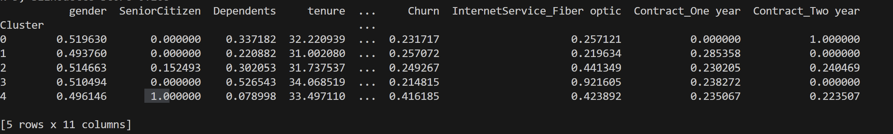
Although overall churn is moderate, Cluster 4 contributes disproportionately to churn, indicating that targeted senior-focused retention strategies could significantly reduce total churn.

Cluster Visualisation
Multiple visualisation techniques were used to enhance interpretability:
Churn Rate by Cluster
A bar chart was used to compare churn rates across clusters, clearly highlighting high-risk and low-risk customer segments.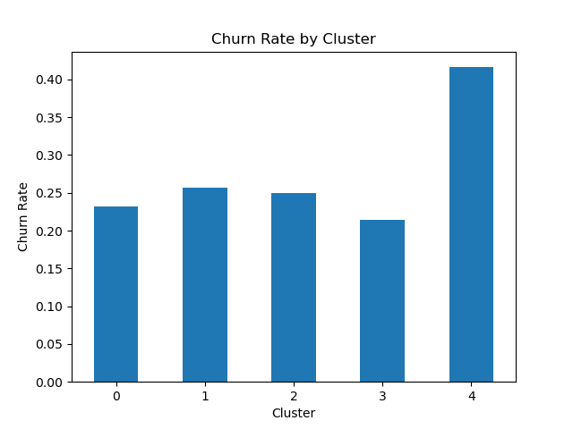

Cluster Size Distribution

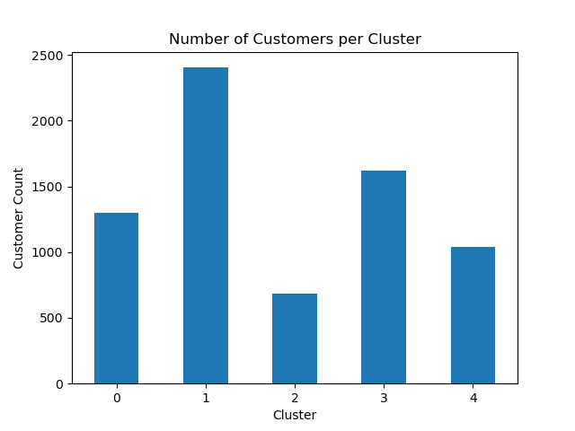
A bar chart illustrated the number of customers within each cluster, providing insight into segment proportions and business impact.
PCA-Based Cluster Segmentation
Principal Component Analysis (PCA) reduced the high-dimensional feature space into two dimensions. A scatter plot was created to visualise cluster separation, with:
- Each point representing a customer
- Colour indicating cluster membership
- A legend included on the same figure for clarity
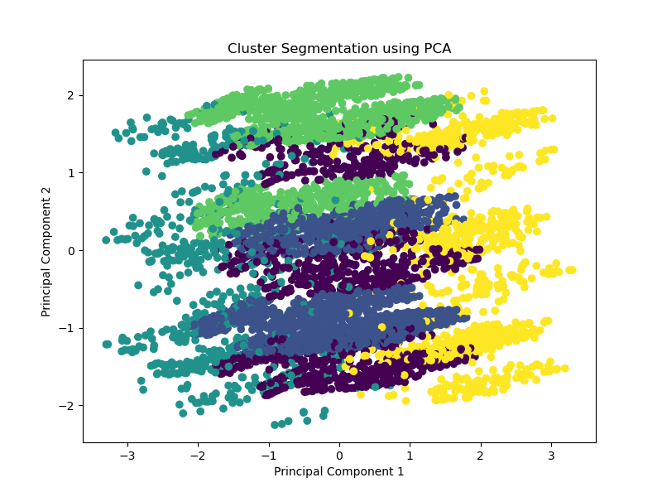
This visualisation confirmed that the clusters formed meaningful groupings in reduced-dimensional space.

Summary of Clustering Outcomes
The clustering analysis successfully identified five distinct customer segments with meaningful differences in demographic composition, service usage, contract type, and churn behaviour. Notably, customers on long-term contracts and those with stable service usage patterns demonstrated lower churn likelihood, while senior customer segments and customers with less stable contractual arrangements exhibited higher churn risk. These insights provide a strong foundation for developing targeted customer retention strategies and data-driven business interventions.

